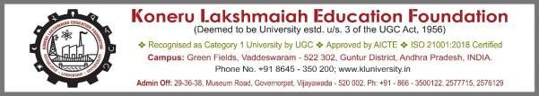

SAMYAK-25

Tech Integration Relay - Event Information

Date: 09/10/2025

Department Name : CSE-3
Event Name : Tech Integration Relay
Event Date(s) : 09/10/2025 Event Duration (Hrs./Days) : 4 HRS
Event Venue / Room No. : C509
Resource Person Name : Dr P NAGESH Designation & Address of
Resource Person : Asst. Professor Faculty Coordinator EMP.ID : 4826
Faculty Coordinator Name : Yateesh Gutti
Faculty Coordinator Email-ID : yateesh@kluniversity.in
Description of the Event : The Tech Integration Relay Contest is a one-day competitive event designed to test participants’ ability to integrate multiple technologies under time pressure. Starting at 10:00 AM and running through 5:30 PM, this relay-style format requires teams to complete a sequence of technological challenges each building on the previous one within a fixed time window.
Under the supervision of Dr. P. Nagesh, Assistant Professor of CSE (ID 4826), competitors from section CSE-3 will take part in a relay sequence. Student coordinator Name Mr Doppalapudi Rohith (reg id 2300032156) is listed as one of the participants team leads. Throughout the day, teams will pass “batons” of tasks that involve software, hardware, networking, or integrated systems design — demanding strong teamwork, quick thinking, and technical versatility.

- Relay format: each stage must be completed before moving to the next
- Mixed technology tasks: coding, debugging, system integration, connectivity
- Time-constrained environment: maintain accuracy under pressure
- Collaborative teamwork: coordination and task handover are critical

Geotagged Photographs of the event

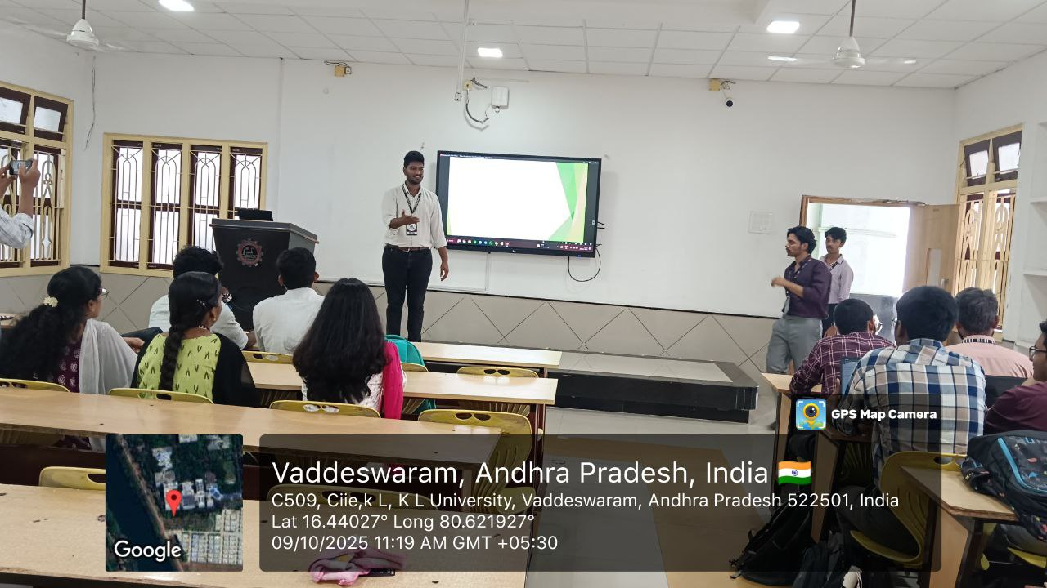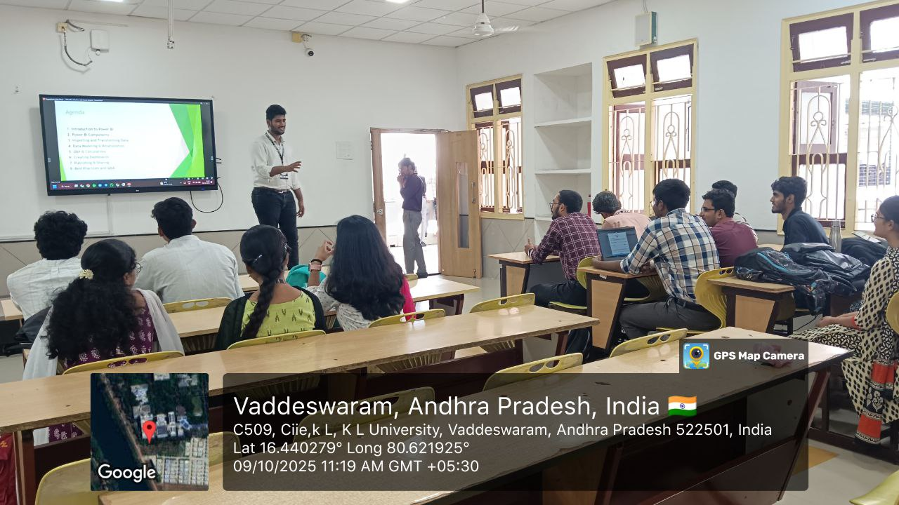
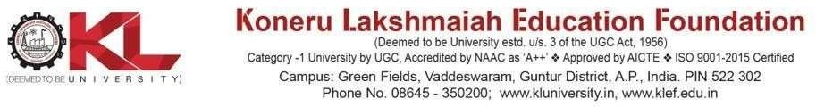

- The Tech Integration Relay Contest incorporates elements from multiple learning theories to create an engaging and effective learning environment. By blending constructivist approaches with behaviorist reinforcement, cognitive challenges, social collaboration, experiential learning, and connectivism networking, the contest fosters a comprehensive learning experience. Participants not only apply technical skills but also develop critical thinking, problem-solving, and collaborative abilities essential for success in the digital age.
Output :
- Students improves Test ability to integrate disparate technologies under pressure
- Sharpen team communication, planning & handover strategies
- Gain experience in a realistic, time-sensitive development environment

EVENT POSTER:
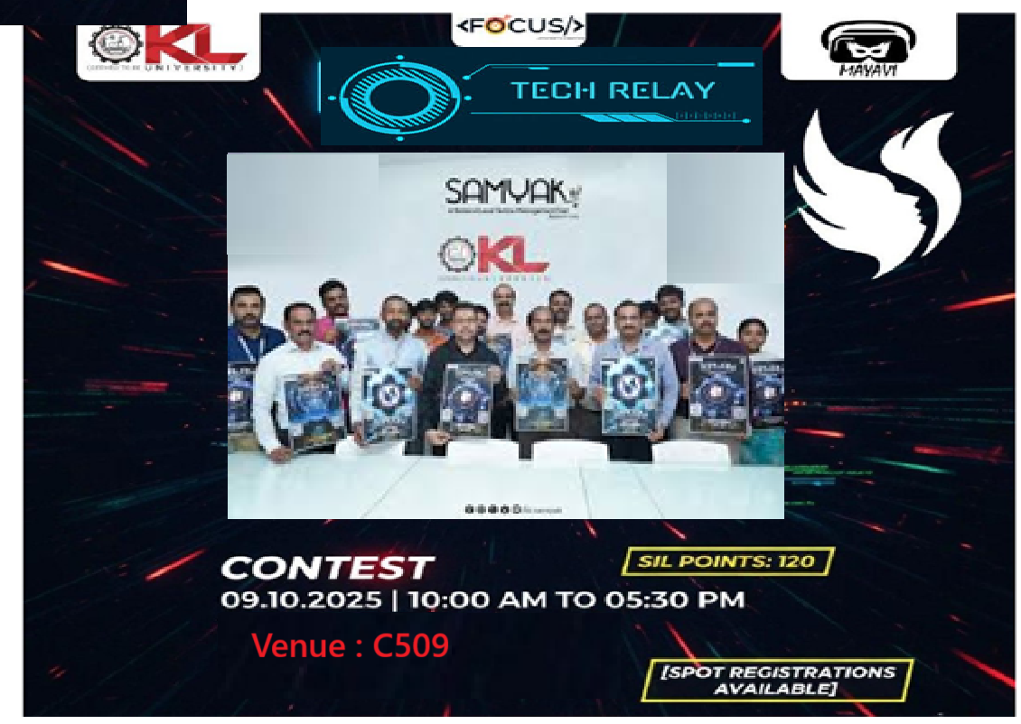

Signature of Faculty Coordinator Signature of HOD Signature of Convener
SAMYAK-25



